ONLINE BANKING SYSTEM

PROJECT REPORT
Technologies Used
Java Swing, JDBC and MySQL
Submitted By
Simran Joshi
Year: 2026

INDEX
1. Introduction
The Online Banking System is a desktop-based banking application developed using Java Swing, JDBC, and MySQL. The application provides users with essential banking functionalities such as registration, login, account creation, deposits, withdrawals, fund transfers, and transaction history management through an interactive graphical user interface.
The project aims to demonstrate the implementation of database connectivity, transaction processing, and user-friendly software design using Java technologies. The system securely stores and manages banking information using a MySQL database and enables users to perform banking operations efficiently.
The application follows a modular structure consisting of graphical user interface components, data access objects (DAO), database connectivity modules, and transaction management functionalities. This architecture ensures maintainability, scalability, and efficient interaction between the user interface and database.
2. Objectives
• To develop a banking application using Java.
• To implement a graphical user interface using Java Swing.
• To establish connectivity between Java and MySQL using JDBC.
• To provide secure user registration and authentication.
• To manage customer accounts efficiently.
• To perform deposit, withdrawal, and fund transfer operations.
• To maintain transaction history records.
• To provide a user-friendly banking experience.

3. Technologies Used

Technology | Purpose
Java | Core Application Development
Swing | Graphical User Interface Development
JDBC | Database Connectivity
MySQL | Database Management
VS Code | Code Development and Testing

4. System Architecture

The system follows a layered architecture where users interact with the Java Swing graphical interface. The GUI communicates with the DAO layer, which contains the business logic and database operations. JDBC is used to establish communication with the MySQL database for storing and retrieving banking information.

5. Database Design
The Online Banking System uses MySQL as its backend database. The database is designed to store user information, account details, and transaction records. Three main tables were created to manage banking operations efficiently.
Users Table
Field Name | Data Type | Description
user_id | INT | Unique User ID
username | VARCHAR | Username
password | VARCHAR | User Password
full_name | VARCHAR | Full Name

Accounts Table
Field Name | Data Type | Description
account_id | INT | Unique Account ID
user_id | INT | Linked User ID
account_number | VARCHAR | Account Number
balance | DOUBLE | Account Balance

Transactions Table
Field Name | Data Type | Description
transaction_id | INT | Unique Transaction ID
account_id | INT | Linked Account ID
transaction_type | VARCHAR | Deposit/Withdraw
amount | DOUBLE | Transaction Amount
transaction_date | TIMESTAMP | Transaction Date

6. Modules Implemented

1. User Registration Module
- This module allows new users to create an account by providing their username, password, and full name. The information is stored securely in the MySQL database.
2. User Login Module
- This module authenticates users by verifying their username and password against the records stored in the database.
3. Account Management Module
- This module enables users to create bank accounts and maintain account information.
4. Deposit Module
- This module allows users to deposit money into their accounts and automatically records the transaction.
5. Withdrawal Module
- This module allows users to withdraw funds from their accounts while validating available balance.
6. Fund Transfer Module
- This module enables users to transfer money from one account to another.
7. Transaction History Module
- This module displays transaction records stored in the database.

7. GUI Screens

Figure 1: Login Screen
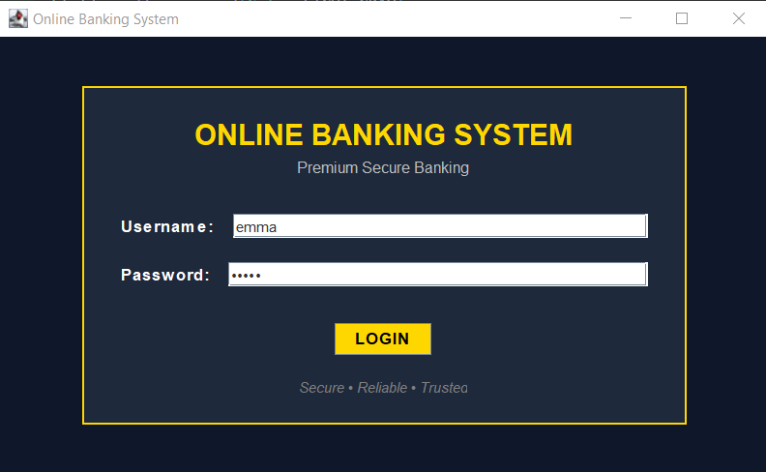
Figure 1 shows the login screen of the Online Banking System.

Figure 2: Dashboard Screen
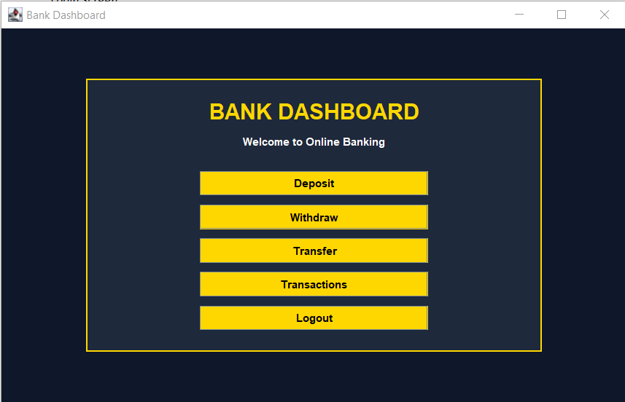
Figure 2 shows the dashboard screen of the Online Banking System.

Figure 3: Deposit Window

Before Depositing Money
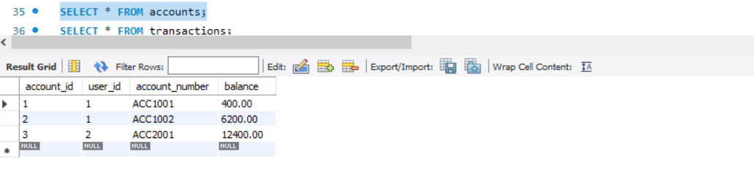

Action of Depositing Money


After Depositing Money
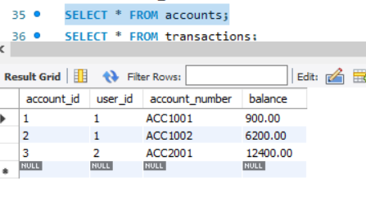

Figure 4: Withdraw Window
Before Withdrawing Money
Action of Withdrawing Money


After Withdrawing Money
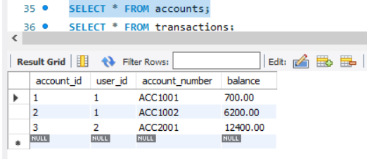

Figure 5: Transfer Window
Before Transferring Money

Action of Transferring Money

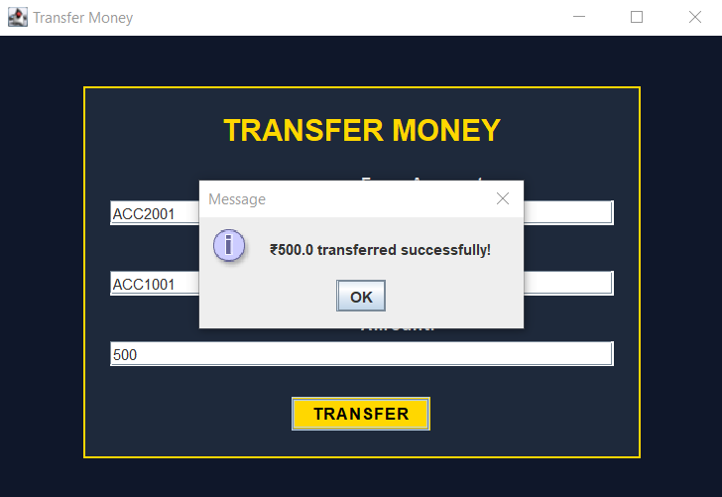
After Transferring Money

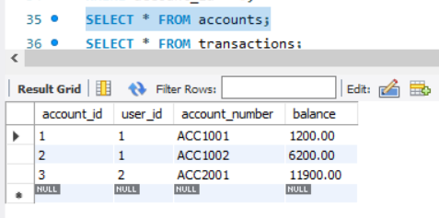

Figure 6: Transaction History Window

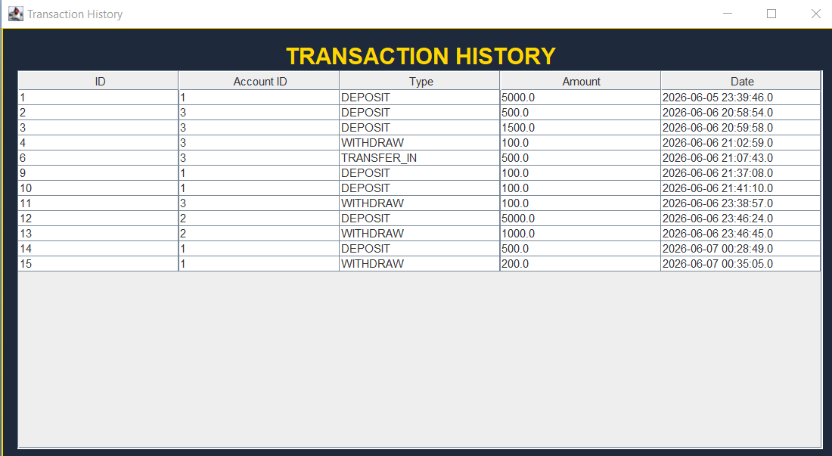
9. Results
The Online Banking System was successfully developed and tested using Java Swing, JDBC, and MySQL. The application successfully performed all intended banking operations through a graphical user interface.
The following functionalities were implemented and verified:
• User Registration – New users were successfully registered and stored in the database.
• User Login – Users were authenticated using their username and password.
• Account Creation – Bank accounts were created and linked to registered users.
• Deposit Operation – Users were able to deposit funds into their accounts, and balances were updated correctly.
• Withdrawal Operation – Users were able to withdraw funds from their accounts while maintaining balance validation.
• Fund Transfer – Money was successfully transferred between accounts.
• Transaction History – Transaction records were stored and displayed successfully.
• Database Integration – All data was stored and retrieved from the MySQL database using JDBC connectivity.
The test results confirmed that the application performed all banking operations accurately and efficiently.
10. Future Enhancements
Although the current version of the Online Banking System successfully performs essential banking operations, several enhancements can be implemented in future versions to improve functionality and security.
Future improvements may include:
• Password encryption for enhanced security.
• User profile management and account settings.
• Account balance dashboard with graphical reports.
• Email and SMS notifications for transactions.
• Admin panel for managing users and accounts.
• Online bill payment functionality.
• Loan and fixed deposit management modules.
• Mobile application integration.
• Multi-user role management system.
These enhancements would make the application more secure, scalable, and suitable for real-world banking environments.

11. CONCLUSION
The Online Banking System was successfully designed and implemented using Java Swing, JDBC, and MySQL. The project provided practical experience in database management, graphical user interface development, and transaction processing.
The application enables users to perform essential banking operations such as registration, login, account creation, deposits, withdrawals, fund transfers, and transaction history management through a user-friendly interface.
The project demonstrates the effective integration of Java technologies with a relational database system and provides a strong foundation for understanding real-world banking application development. Overall, the project successfully achieved its objectives and delivered a functional and reliable banking management system.

